Ariba Sourcing – Business Blueprint Document

Prepared by Ernst & Young LLP

***Document Control***

|  |  |
| --- | --- |
| **General Document Information** | |
| Name of the document | Business Blueprint Document |
| Technical scope | Implementation of Ariba Sourcing and Integration with S4HANA ERP |

|  |  |  |  |
| --- | --- | --- | --- |
| **Review History** | | | |
| **Document Version** | | **V.01** | |
| Created By: |  | Created Date: |  |
| Reviewed By: |  | Review Date: |  |
| EY Project Manager |  | Review Date: |  |
| Project Manager |  | Review Date / Signoff Date: |  |

|  |  |  |  |  |
| --- | --- | --- | --- | --- |
| **Approval History** | | | | |
| **Name** | **Designation** | **Business/Plant** | **Sign-off date** | **Signature** |
|  |  |  |  |  |

|  |  |  |  |  |
| --- | --- | --- | --- | --- |
| **Document Version** | | | | |
| **Version Number** | **Modified By** | **Reviewed By** | **Release Date** | **Modification Done** |
| V1.0 |  |  |  |  |
| V2.0 |  |  |  |  |

**Contents**

1. Introduction ......................................................................................................................................... 3

1.1 Objective................................................................................................................................. 3

1.2 Sign Off Parties ...................................................................................................................... 3

1.3 Business Blueprint Document (BPD) Change Governance ................................................... 3

2. Introduction – SAP ARIBA .................................................................................................................. 3

2.1 SAP ARIBA Process Overview .............................................................................................. 4

3. Business Process Master List (BPML)................................................................................................ 4

4. Master Data……………………………................................................................................................. 4

5. Business Process Description (As-Is Process) …………………………………………………….………5

5.1 Process Flow Diagram- As-Is Process ................................................................................. 5

6. Business Process Description (To-BE Process) …………………………………………………………12

6.1 Process Flow Diagram- To-be Process: .............................................................................. 12

7. Sourcing Process Explanation ...........................................................................................................23

8. Staging table for allocation of released PR to automate RFQ / creation of Sourcing Request….......25

9. Change impact to existing process...…………………….....................................................................26

10. Configuration Detail…………….………………………….....................................................................26

11. ADDENDUM ..................................................................................................................................... 27

12. APPENDIX ........................................................................................................................................ 27

12.1 Requirement Gathering Sheet: ............................................................................................ 27

12.2 Authorisation Control Matrix ................................................................................................. 27

13. Glossary…… ..................................................................................................................................... 28

1. **Introduction**

**1.1 Objective**

This document describes the key business processes for SAP ARIBA Sourcing and the related enterprise structure definitions. This document is intended to provide a holistic view of all the key elements of the design including organization/roles, technology, process and data requirements in a format and language that is appropriate for business review and sign-off.

The sign-off of this document concludes the Design Phase and serves as inputs to the Build / Test Phase.

**1.2 Sign Off Parties**

Key business representatives and process owners from:

* s Business Process Owners (BPOs)
* <Customer Name> Business Process Leads (BPLs)

**1.3 Business Blueprint Document (BPD) Change Governance**

Below is the process that will be followed to track the updates to the document:

* The BPDs are initially released as v0.1.
* All amendments made to the BPD henceforth, as part of the design phase and during review
* Sessions will be captured as new versions incrementing by 0.1 (e.g. v0.1, v0.2, and so on).
* When the version is ready to be issued for sign-off, the version should be raised to the next Whole number. For e.g., if the current version is at v0.2 and it is ready of sign-off, the version would be raised to 1.0 and Revision History section should be updated with the comments “Issued for sign-off’.

1. **Introduction – SAP ARIBA**

Ariba Sourcing is used to source goods and services across different categories. This module allows entities to conduct their sourcing event from start to end, including creating and posting documents, receiving electronic responses, and finding the winning supplier. The sourcing events include forward and reverse auctions, Request for Information, Request for Proposals, etc. Through the sourcing module, entities are also able to leverage the Ariba Network.

SAP Ariba is an online solution catered to delivering a cloud-based procurement platform for the needs of both buyers and suppliers. It is touted as one of the world’s leading business commerce networks where businesses of all sizes can connect to their trading partners anywhere, at any time, and from any application or device to buy, sell, and manage their cash more efficiently than before.

**2.1 SAP Ariba Process Overview**

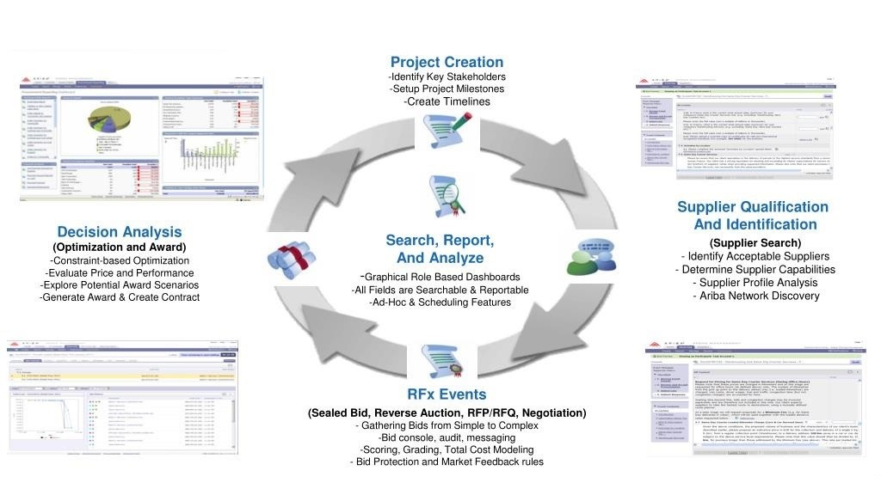

# Business Process Master List (BPML)

* Following are the list of scenarios for Sourcing across categories
* Contract Development Services (CDS)
* Chemistry FSS
* Chemistry FTE
* Opex (Material / Services)
* Biology
* Product
* Capex CJF

1. **Master Data**

Master Data is the core data that is used as a base for any transaction in an organization. Data that is created centrally and is valid for all applications. It remains constant over time, but we need to update it on a regular basis.

Material Master in Ariba consists of below data:

* Company Code: It is a legal entity of Financial Accounting for which is used to draw individual financial statements for purpose of external reporting.
* Commodity Code: These are standard classification codes for products and services used to detail

where money is spent within a company. It is grouping of “material group” of SAP.

There are approximately 38-40 commodity codes (refer annexures of Enablement

Workbook for details)

* Department: These are used to identify internal business units for projects. This is the combination of Plant code and function specific to a plant (refer annexures of enablement workbook for details)
* Region/Plant: These are geographical areas that allow you to filter information based on each user's region. In SAP Ariba Sourcing, you can specify conditions that make documents or tasks appear in created projects only when the region is set to a specific value, such as USA.
* User/Supplier Data: Users are the Project Owner/Creator who are known as Enterprise User. Suppliers are organization which are invited to participate in the events.

**5. Business Process Description (As-Is Process)**

**5.1 As-Is Process**

**Contract Development Services (CDS)**

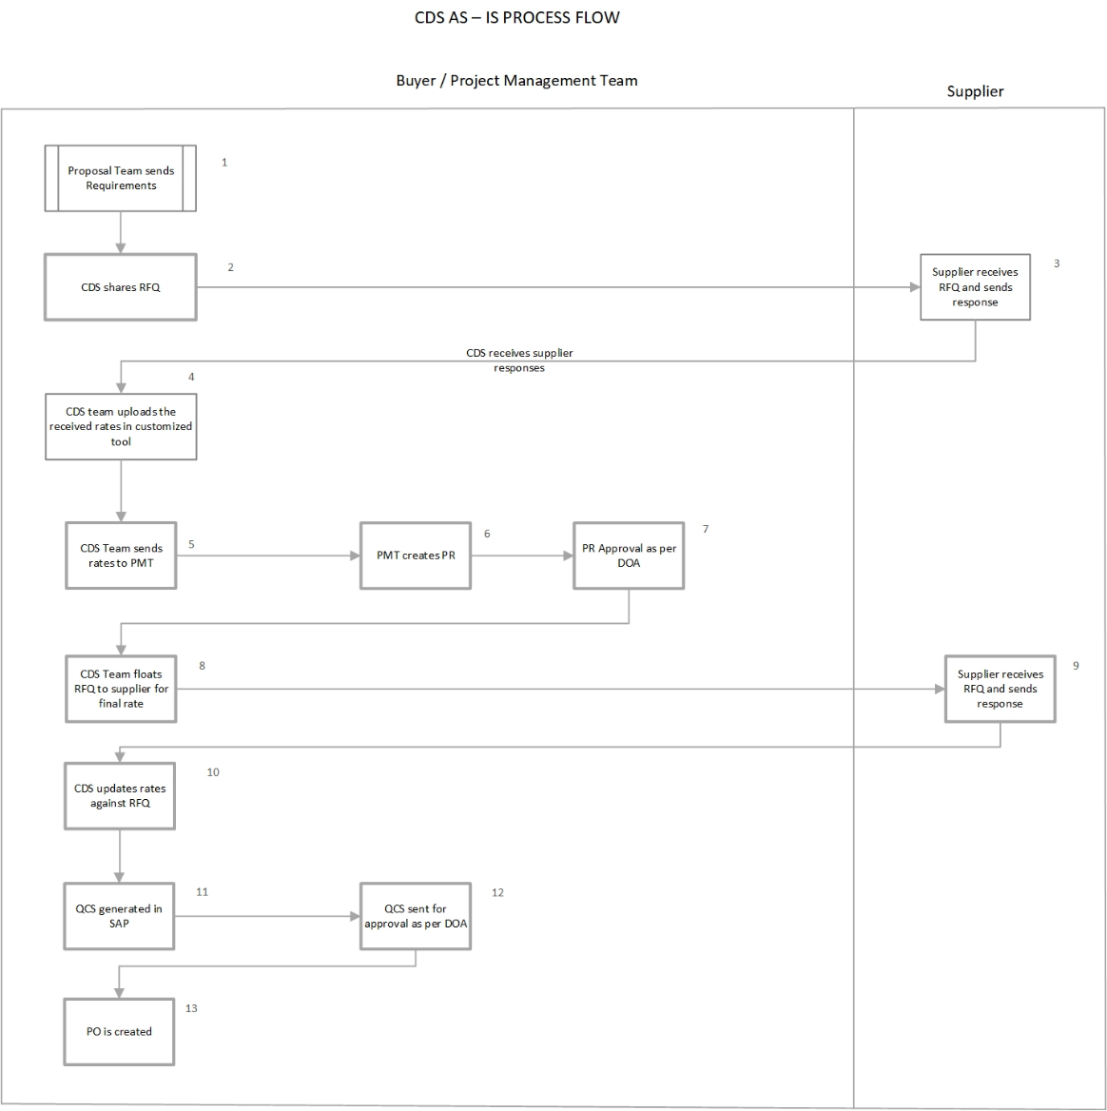

|  |  |
| --- | --- |
| **Steps** | **As Is Process – Contract Development Services (CDS)** |
| 1 | Proposal team shares requirement to CDS team in excel format |
| 2 | CDS shares the RFQ with vendor in excel |
| 3 | Receive vendor responses |
| 4 | CDS team upload the rates of vendor in customized tool |
| 5 | CDS team shares the estimated rates with proposal team |
| 6 | Proposal team creates PR in case they win the project within spam of 3 or 6 month |
| 7 | PR approval as per DOA |
| 8 | Against approved PR CDS team float RFQ again through SAP to each vendor individually to receive the final rates |
| 9 | Vendors respond to RFQ and shares the prices in excel over email |
| 10 | CDS team update the rates against each RFQ sent to vendor |
| 11 | QCS gets generated in SAP via custom program |
| 12 | QCS sent for approval as per DOA |
| 13 | PO created against approved vendor |

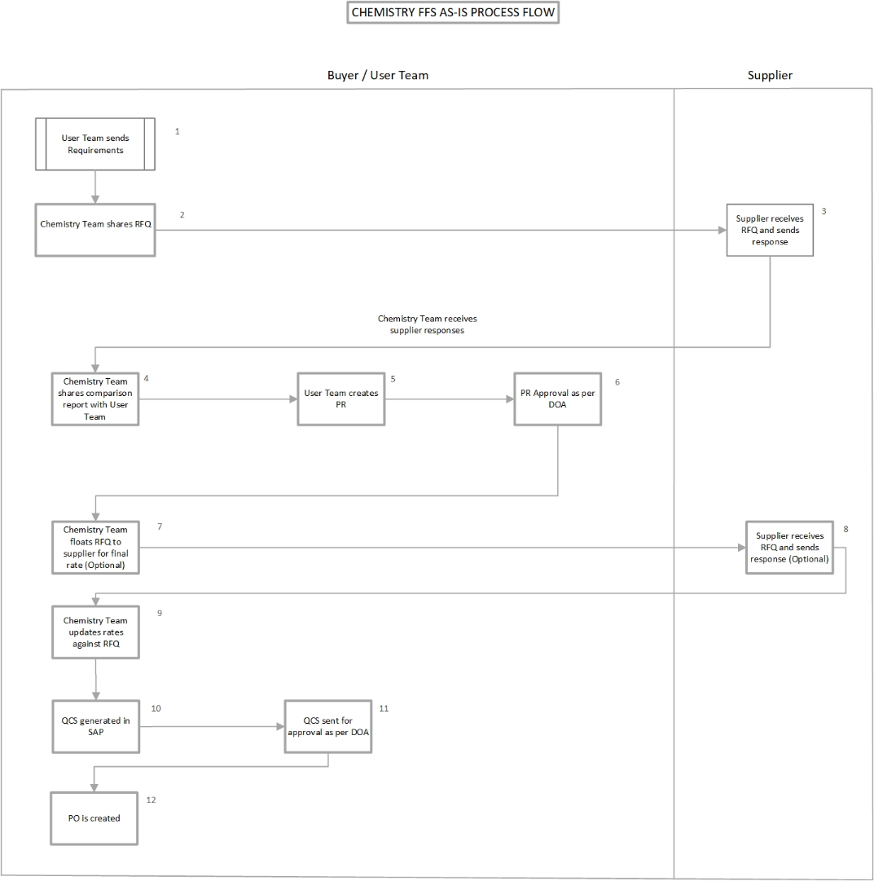**Chemistry FSS**

|  |  |
| --- | --- |
| **Steps** | **As Is Process - Chemistry FSS** |
| 1 | User team shares requirement to Chemistry team in excel format |
| 2 | Chemistry team shares the RFQ with vendor in excel |
| 3 | Receive vendor responses |
| 4 | Chemistry team shares comparison report with User |
| 5 | User team creates PR |
| 6 | PR approval as per DOA |
| 7 | Against approved PR Chemistry team float RFQ again through SAP to each supplier individually to receive the final rates |
| 8 | Vendor respond to RFQ and shares the prices in excel over email |
| 9 | Chemistry team update the rates against each RFQ sent to vendor |
| 10 | QCS gets generated in SAP via custom program |
| 11 | QCS sent for approval as per DOA |
| 12 | PO created against approved vendor |

**Chemistry FTE**

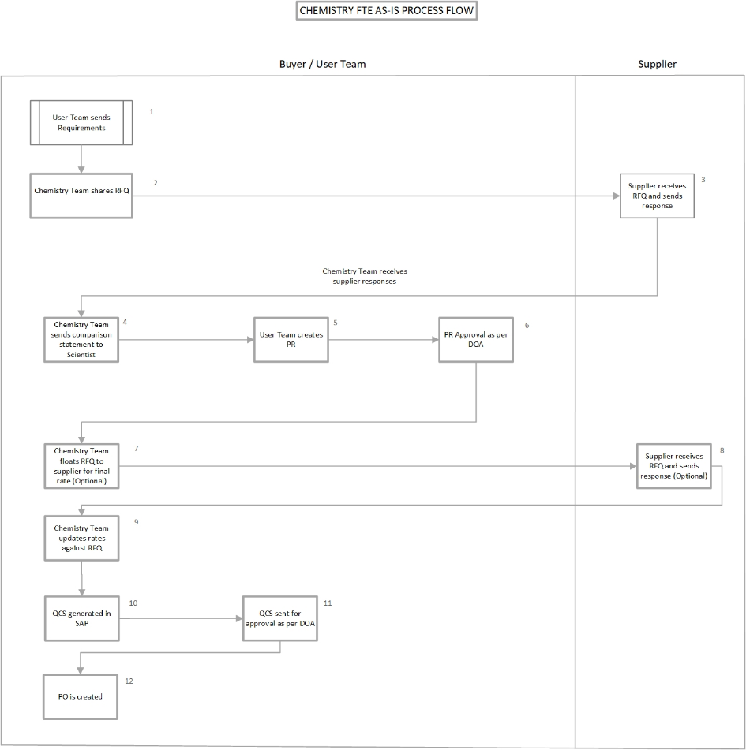

|  |  |
| --- | --- |
| **Steps** | **As Is Process - Chemistry FTE** |
| 1 | User team shares requirement to Chemistry team in excel format |
| 2 | Chemistry team shares the RFQ with vendors in excel |
| 3 | Receive vendors responses |
| 4 | Chemistry team shares the comparison with scientist |
| 5 | User team creates PR in SAP |
| 6 | PR approval as per DOA |
| 7 | Against approved PR Chemistry team float RFQ again through SAP to each vendor individually to receive the final rates |
| 8 | Vendors respond to RFQ and shares the prices in excel over email |
| 9 | Chemistry team update the rates against each RFQ sent to vendors |
| 10 | QCS gets generated in SAP via custom program |
| 11 | QCS sent for approval as per DOA |
| 12 | PO created against approved vendor |

**Biology**

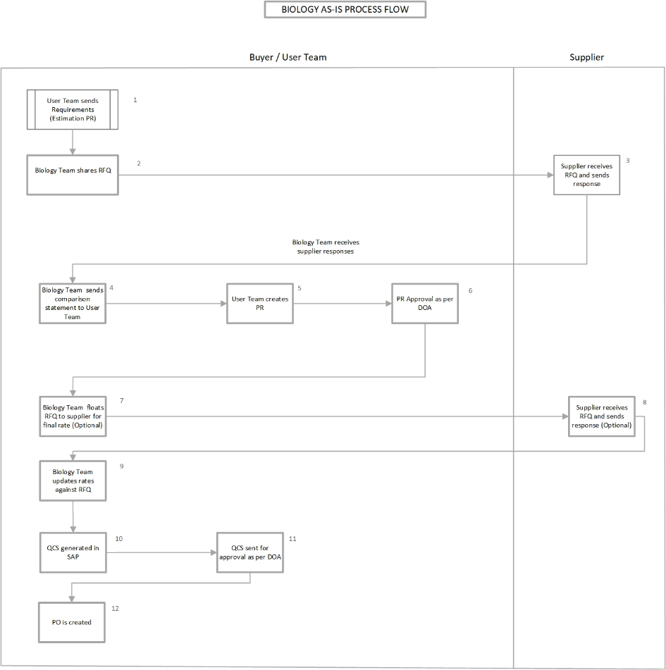

|  |  |
| --- | --- |
| **Steps** | **As Is Process - Biology** |
| 1 | User team creates estimated PR |
| 2 | PR approval as per DOA |
| 3 | RFQ shared with all suppliers individually through SAP |
| 4 | Receive Supplier responses on email |
| 5 | Biology team shares comparison with the user team |
| 6 | User team create actual PR |
| 7 | PR approval as per DOA |
| 8 | Against approved PR Biology team float RFQ again through SAP to each vendor individually to receive the final rates |
| 9 | Vendors respond to RFQ and shares the prices in excel over email |
| 10 | Biology team update the rates against each RFQ sent to supplier |
| 11 | QCS gets generated in SAP via custom program |
| 12 | QCS sent for approval as per DOA |
| 13 | PO created against approved vendor |

**Opex (Material & Service)**

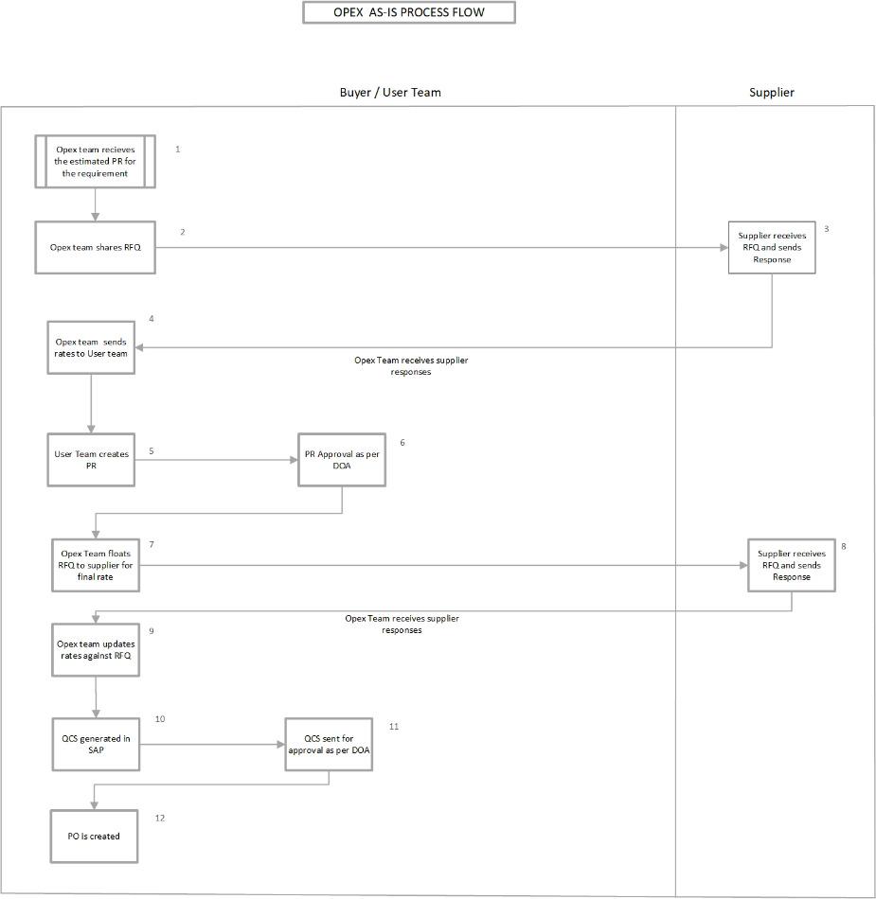

|  |  |
| --- | --- |
| **Steps** | **As Is Process - Opex (Material & Services)** |
| 1 | Opex team receives the estimated PR for the requirement |
| 2 | RFQ shared with all suppliers individually through SAP |
| 3 | Receive Supplier responses on email |
| 4 | Opex team shares the estimated rates with user team |
| 5 | User team creates PR in SAP |
| 6 | PR approval as per DOA |
| 7 | Against approved PR Opex team float RFQ again through SAP to each supplier individually to receive the final rates |
| 8 | Suppliers respond to RFQ and shares the prices in excel over email |
| 9 | Opex team update the rates against each RFQ sent to supplier |
| 10 | QCS gets generated in SAP via custom program |
| 11 | QCS sent for approval as per DOA |
| 12 | PO created against approved vendor |

**Product**

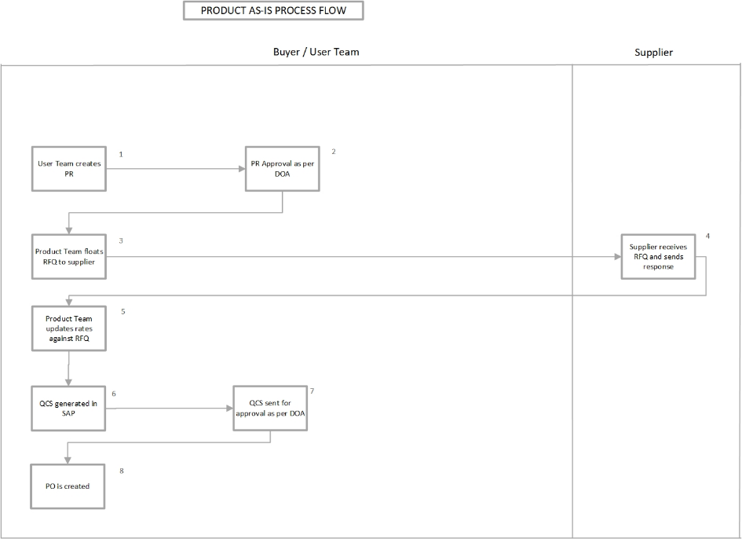

|  |  |
| --- | --- |
| **Steps** | **As Is Process – Product** |
| 1 | User team creates PR |
| 2 | PR approval as per DOA |
| 3 | RFQ shared with all suppliers individually through SAP |
| 4 | Receive Supplier responses on email |
| 5 | Product team update the rates against each RFQ sent to supplier |
| 6 | QCS gets generated in SAP via custom program |
| 7 | QCS sent for approval as per DOA |
| 8 | PO created against approved vendor |

**Capex Justification Process**

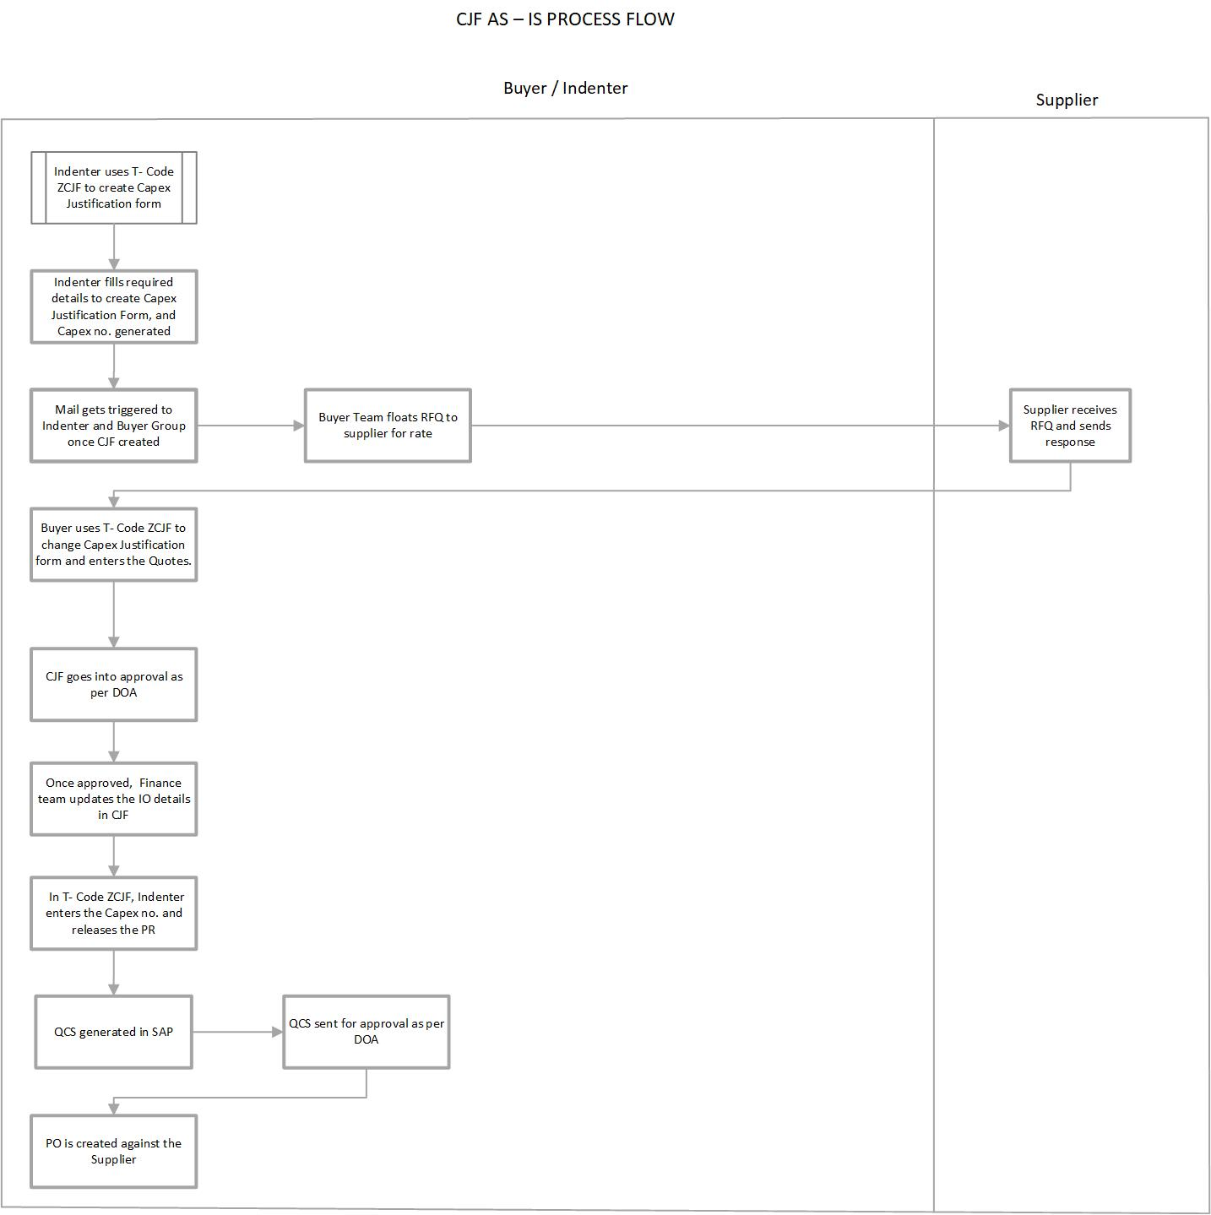

|  |  |
| --- | --- |
| **Steps** | **As Is Process – Capex Justification Form** |
| 1 | Indenter uses T- Code ZCJF to create Capex Justification form |
| 2 | Indenter fills required details to create Capex Justification Form, and Capex no. generated |
| 3 | Mail gets triggered to Indenter and Buyer Group once CJF created |
| 4 | Buyer Team floats RFQ to supplier for rate |
| 5 | Supplier receives RFQ and sends response |
| 6 | Buyer uses T- Code ZCJF to change Capex Justification form and enters the Quotes |
| 7 | CJF goes into approval as per DOA |
| 8 | Once CJF approved, Finance team updates the IO details in CJF |
| 9 | In T- Code ZCJF, Indenter enters the Capex no. and releases the PR |
| 10 | QCS generated in SAP |
| 11 | QCS sent for approval as per DOA |
| 12 | PO is created against the Supplier |

**6. Business Process Description (To-Be Process)**

**6.1 To-Be Process**

**Contract Development Services (CDS)**

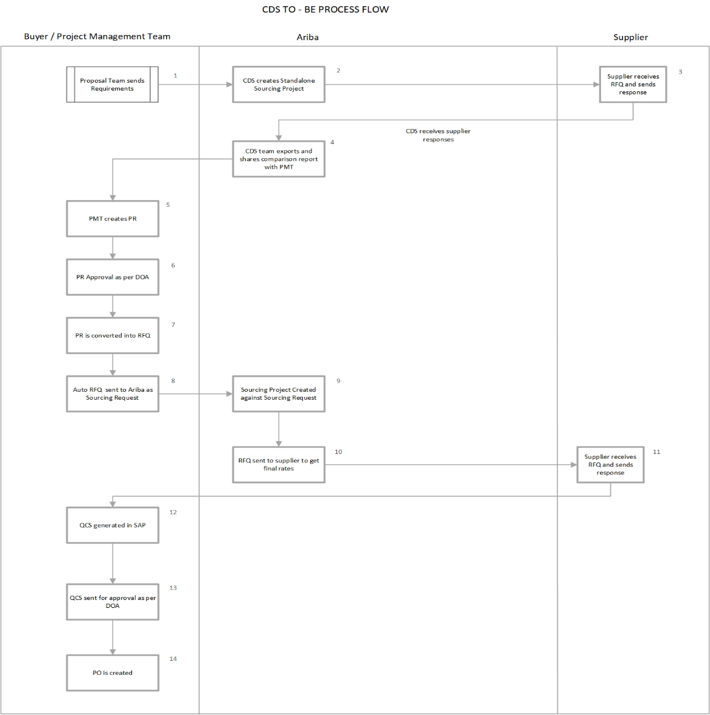

|  |  |  |  |  |
| --- | --- | --- | --- | --- |
| **Steps** | **Process Tasks** | **Description** | **Role** | **Mode** |
| 1 | Sourcing Project Creation | CDS will create the Sourcing Project directly in Ariba based on the requirement received from proposal team | Sourcing Executive | Ariba User Portal |
| 2 | RFQ Creation | RFQ will be sent to all supplier | Sourcing Executive | Ariba User Portal |
| 3 | Supplier Participation | Receive Supplier responses | Supplier | Ariba Supplier Portal |
| 4 | Comparative Generation | CDS team will export the standard Ariba comparison report and share with proposal team | Sourcing Executive | Ariba User Portal |
| 5 | PR Creation | Proposal team creates PR in case they win the project within spam of 3 or 6 month | User | S/4H System |
| 6 | PR Approval | PR approval as per DOA | Approver | S/4H System |
| 7 | PR Consolidation | PR consolidation to generate single RFQ | Sourcing Executive | S/4H System |
| 8 | RFQ Creation | RFQ creation automatically in SAP and transmitted to Ariba as sourcing request | Sourcing Executive | S/4H System |
| 9 | Sourcing Project Creation | Sourcing project will be created against sourcing request | Sourcing Executive | Ariba User Portal |
| 10 | RFQ New Round | RFQ will be sent to all supplier to get the final rates | Sourcing Executive | Ariba User Portal |
| 11 | QCS Creation | Task initiation in Ariba to generate QCS in SAP | Sourcing Executive | S/4H System |
| 12 | QCS Approval | QCS sent for approval as per DOA | Approver | S/4H System |

* **Sourcing Executive/Buyer**- The person who is responsible for creating, publishing and monitoring the event. These personals are license user.
* **Supplier**- Person or vendors who are invited to provide the prices for requirement published by the buyer
* **Approver**- Person or vendors who is responsible to approve PR and QCS
* **User-** Person responsible to create PR

**Chemistry FFS**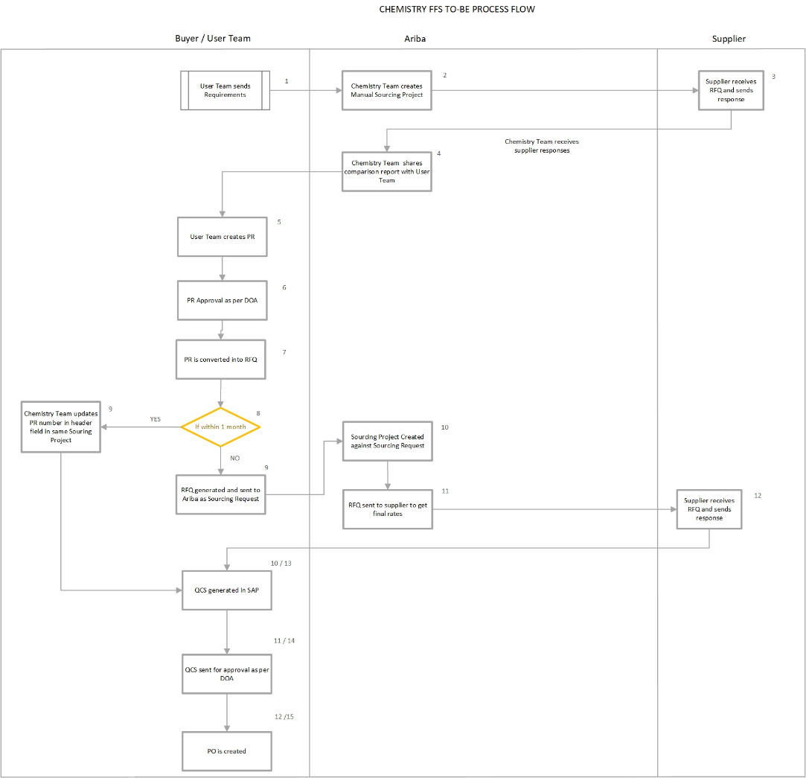

**3.2.2 Process Flow for Biology**

|  |  |  |  |  |
| --- | --- | --- | --- | --- |
| **Steps** | **Process Tasks** | **Description** | **Role** | **Mode** |
| 1 | Sourcing Project Creation | Chemistry team will create the Sourcing Project directly in Ariba based on the requirement received from proposal team | Sourcing Executive | Ariba User Portal |
| 2 | RFQ Creation | RFQ will be sent to all supplier | Sourcing Executive | Ariba User Portal |
| 3 | Supplier Participation | Receive Supplier responses | Supplier | Ariba Supplier Portal |
| 4 | Comparative Generation | Chemistry team will export the standard Ariba comparison report and share with user team | Sourcing Executive | Ariba User Portal |
| 5 | PR Creation | User team creates PR | User | S/4H System |
| 6 | PR Approval | PR approval as per DOA | Approver | S/4H System |
| 7 | Update PR in Sourcing Project **(Option1)** | PR number will be updated manually in the sourcing project and trigger for QCS generation | Sourcing Executive | Ariba User Portal |
| 8 | PR Consolidation **(Option2)** | PR consolidation to generate single RFQ | Sourcing Executive | S/4H System |
| 9 | RFQ Creation | RFQ creation automatically in SAP and transmitted to Ariba as sourcing request | Sourcing Executive | S/4H System |
| 10 | Sourcing Project Creation | Sourcing project will be created against sourcing request | Sourcing Executive | Ariba User Portal |
| 11 | RFQ New Round | RFQ will be sent to all supplier to get the final rates | Sourcing Executive | Ariba User Portal |
| 12 | QCS Creation | Task initiation in Ariba to generate QCS in SAP | Sourcing Executive | S/4H System |
| 13 | QCS Approval | QCS sent for approval as per DOA | Approver | S/4H System |

* **Sourcing Executive/Buyer**- The person who is responsible for creating, publishing and monitoring the event. These personals are license user.
* **Supplier**- Person or vendors who are invited to provide the prices for requirement published by the buyer
* **Approver**- Person or vendors who is responsible to approve PR and QCS
* **User-** Person responsible to create PR

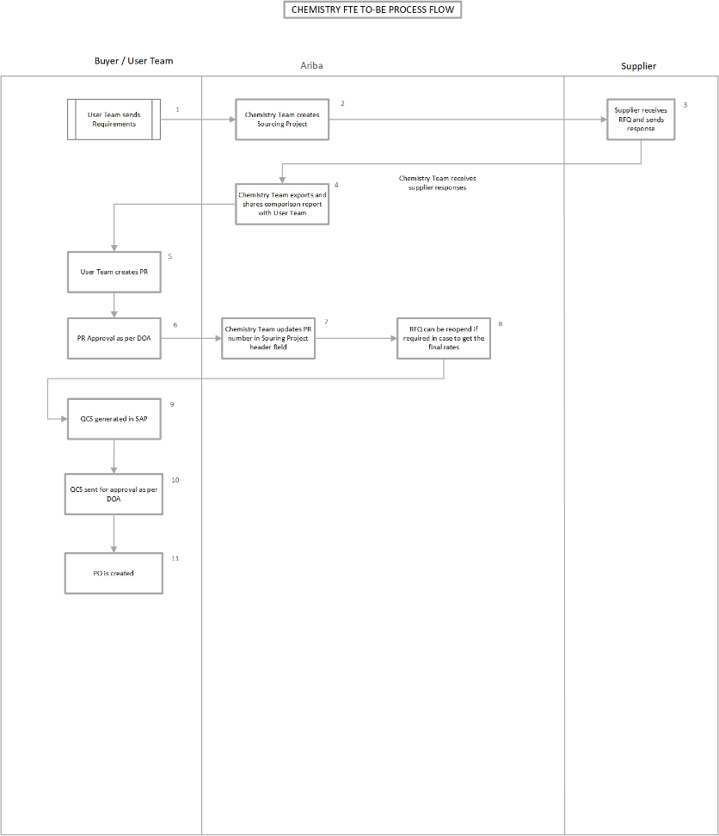**Chemistry FTE**

|  |  |  |  |  |
| --- | --- | --- | --- | --- |
| **Steps** | **Process Tasks** | **Description** | **Role** | **Mode** |
| 1 | Sourcing Project Creation | Chemistry team will create the Sourcing Project directly in Ariba based on the requirement received from user team | Sourcing Executive | Ariba User Portal |
| 2 | RFQ Creation | RFQ will be sent to all supplier | Sourcing Executive | Ariba User Portal |
| 3 | Supplier Participation | Receive Supplier responses | Supplier | Ariba Supplier Portal |
| 4 | Comparative Generation | Chemistry team will export the standard Ariba comparison report and share with user team | Sourcing Executive | Ariba User Portal |
| 5 | PR Creation | PR creation in SAP | User | S/4H System |
| 6 | PR Approval | PR approval as per DOA | Approver | S/4H System |
| 7 | Update PR in Sourcing Project | Chemistry team will update the PR number in the sourcing project manually | Sourcing Executive | Ariba User Portal |
| 8 | QCS Creation | Task initiation in Ariba to generate QCS in SAP | Sourcing Executive | S/4H System |
| 9 | QCS Approval | QCS sent for approval as per DOA | Approver | S/4H System |

* **Sourcing Executive/Buyer**- The person who is responsible for creating, publishing and monitoring the event. These personals are license user.
* **Supplier**- Person or vendors who are invited to provide the prices for requirement published by the buyer
* **Approver**- Person or vendors who is responsible to approve PR and QCS
* **User-** Person responsible to create PR

**Biology**

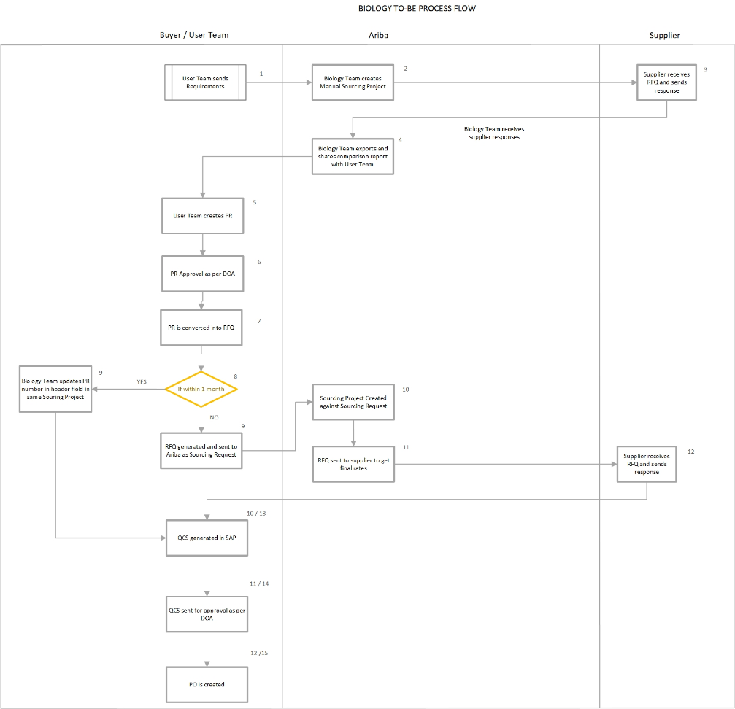

|  |  |  |  |  |
| --- | --- | --- | --- | --- |
| **Steps** | **Process Tasks** | **Description** | **Role** | **Mode** |
| 1 | Sourcing Project Creation | Biology team will create the Sourcing Project directly in Ariba based on the requirement received from user team | Sourcing Executive | Ariba User Portal |
| 2 | RFQ Creation | RFQ will be sent to all supplier | Sourcing Executive | Ariba User Portal |
| 3 | Supplier Participation | Receive Supplier responses | Supplier | Ariba Supplier Portal |
| 4 | Comparative Generation | Biology team will export the standard Ariba comparison report and share with user team | Sourcing Executive | Ariba User Portal |
| 5 | PR Creation | PR creation in SAP | User | S/4H System |
| 6 | PR Approval | PR approval as per DOA | Approver | S/4H System |
| 7 | Update PR in Sourcing Project **(Option1)** | PR number will be updated manually in the sourcing project and trigger for QCS generation | Sourcing Executive | Ariba User Portal |
| 8 | PR Consolidation **(Option2)** | PR consolidation to generate single RFQ | Sourcing Executive | S/4H System |
| 9 | RFQ Creation | Auto RFQ will be created in SAP and transmitted to Ariba as sourcing request | Sourcing Executive | S/4H System |
| 10 | Sourcing Project Creation | Biology team will create the sourcing project against the sourcing request | Sourcing Executive | Ariba User Portal |
| 11 | RFQ Creation | RFQ will be sent to all supplier | Sourcing Executive | Ariba User Portal |
| 12 | Supplier Participation | Receive Supplier responses | Supplier | Ariba Supplier Portal |
| 13 | QCS Generation | Task initiation in Ariba to generate QCS in SAP | Sourcing Executive | S/4H System |
| 14 | QCS Approval | QCS sent for approval as per DOA | Approver | S/4H System |

* **Sourcing Executive/Buyer**- The person who is responsible for creating, publishing and monitoring the event. These personals are license user.
* **Supplier**- Person or vendors who are invited to provide the prices for requirement published by the buyer
* **Approver**- Person or vendors who is responsible to approve PR and QCS
* **User-** Person responsible to create PR

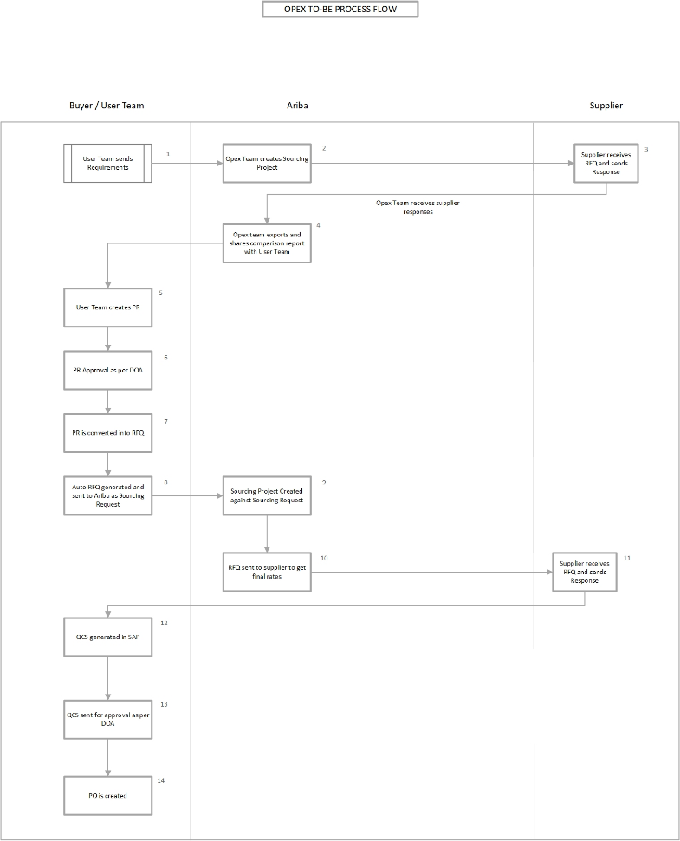**Opex (Material and Service)**

|  |  |  |  |  |
| --- | --- | --- | --- | --- |
| **Steps** | **Process Tasks** | **Description** | **Role** | **Mode** |
| 1 | PR Creation | Estimated PR will be created in SAP | User | S/4H System |
| 2 | PR Approval | PR approval as per DOA | Approver | S/4H System |
| 3 | PR Consolidation | PR consolidation to generate single RFQ | Sourcing Executive | S/4H System |
| 4 | RFQ Creation | Auto RFQ will be created in SAP and transmitted to Ariba as sourcing request | Sourcing Executive | S/4H System |
| 5 | Sourcing Project Creation | Opex team will create the sourcing project against the sourcing request | Sourcing Executive | Ariba User Portal |
| 6 | RFQ Creation | RFQ will be sent to all supplier | Sourcing Executive | Ariba User Portal |
| 7 | Supplier Participation | Receive Supplier responses | Supplier | Ariba Supplier Portal |
| 8 | Comparative Generation | Opex team will export the standard Ariba comparison report and share with Opex team | Sourcing Executive | Ariba User Portal |
| 9 | PR Creation | User team creates PR in SAP | User | S/4H System |
| 10 | PR Approval | PR approval as per DOA | Approver | S/4H System |
| 11 | PR Consolidation | PR consolidation to generate single RFQ | Sourcing Executive | S/4H System |
| 12 | RFQ Creation | Auto RFQ will be created in SAP and transmitted to Ariba as sourcing request | Sourcing Executive | S/4H System |
| 13 | Sourcing Project Creation | Opex team will create the sourcing project against the sourcing request | Sourcing Executive | Ariba User Portal |
| 14 | RFQ Creation | RFQ will be sent to all supplier to get the final rates | Sourcing Executive | Ariba User Portal |
| 15 | Supplier Participation | Receive Supplier responses | Supplier | Ariba Supplier Portal |
| 16 | QCS Generation | Task initiation in Ariba to generate QCS in SAP | Sourcing Executive | S/4H System |
| 17 | QCS Approval | QCS sent for approval as per DOA | Approver | S/4H System |

* **Sourcing Executive/Buyer**- The person who is responsible for creating, publishing and monitoring the event. These personals are license user.
* **Supplier**- Person or vendors who are invited to provide the prices for requirement published by the buyer
* **Approver**- Person or vendors who is responsible to approve PR and QCS
* **User-** Person responsible to create PR

**Product**

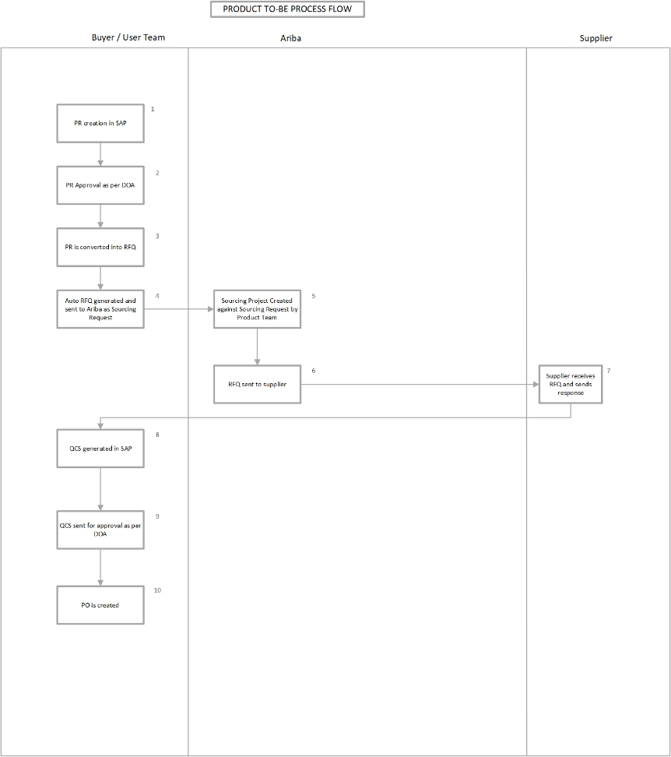

|  |  |  |  |  |
| --- | --- | --- | --- | --- |
| **Steps** | **Process Tasks** | **Description** | **Role** | **Mode** |
| 1 | PR Creation | PR creation in SAP | User | S/4H System |
| 2 | PR Approval | PR approval as per DOA | Approver | S/4H System |
| 3 | PR Consolidation | PR consolidation to generate single RFQ | Sourcing Executive | S/4H System |
| 4 | RFQ Creation | Auto RFQ will be created in SAP and transmitted to Ariba as sourcing request | Sourcing Executive | S/4H System |
| 5 | Sourcing Project Creation | Product team will create the sourcing project against the sourcing request | Sourcing Executive | Ariba User Portal |
| 6 | RFQ Creation | RFQ will be sent to all supplier | Sourcing Executive | Ariba User Portal |
| 7 | Supplier Participation | Receive Supplier responses | Sourcing Executive | Ariba Supplier Portal |
| 8 | QCS Generation | Task initiation in Ariba to generate QCS in SAP | Sourcing Executive | S/4H System |
| 9 | QCS Approval | QCS sent for approval as per DOA | Approver | S/4H System |

* **Sourcing Executive/Buyer**- The person who is responsible for creating, publishing and monitoring the event. These personals are license user.
* **Supplier**- Person or vendors who are invited to provide the prices for requirement published by the buyer
* **Approver**- Person or vendors who is responsible to approve PR and QCS
* **User-** Person responsible to create PR

**Capex Justification Process**

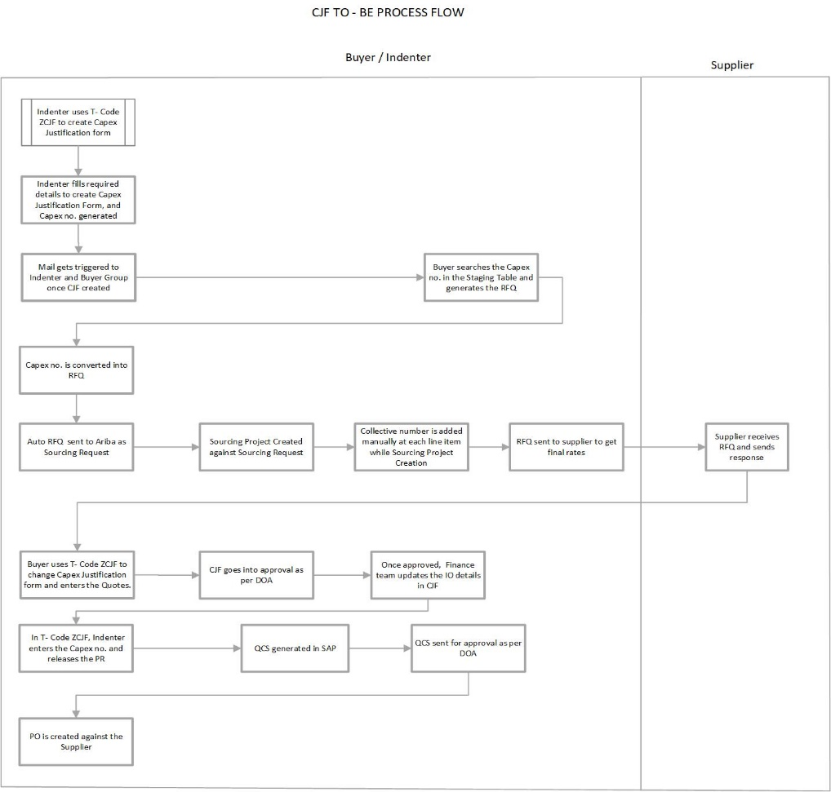

|  |  |  |  |  |
| --- | --- | --- | --- | --- |
| **Steps** | **Process Tasks** | **Description** | **Role** | **Mode** |
| 1 | CJF Creation | Indenter uses T- Code ZCJF to create Capex Justification form | Indenter | S/4H System |
| 2 | CJF Creation | Indenter fills required details to create Capex Justification Form, and Capex no. generated | Indenter | S/4H System |
| 3 | RFQ Creation | Buyer searches the Capex no. in the Staging Table and generates the RFQ | Sourcing Executive | S/4H System |
| 4 | Sourcing Project Creation | Sourcing Project Created against Sourcing Request | Sourcing Executive | Ariba User Portal |
| 5 | Sourcing Project Creation | Collective number is added manually at each line item while Sourcing Project Creation | Sourcing Executive | Ariba User Portal |
| 6 | RFQ Creation | RFQ sent to supplier to get final rates | Sourcing Executive | Ariba User Portal |
| 7 | Supplier Participation | Supplier receives RFQ and sends response | Supplier | Ariba Supplier Portal |
| 8 | Modification in CJF | Buyer uses T- Code ZCJF to change Capex Justification form and enters the Quotes. | Sourcing Executive | S/4H System |
| 9 | CJF Approval | CJF goes into approval as per DOA | Approver | S/4H System |
| 10 | Updating IO Details | Once approved, Finance team updates the IO details in CJF | Finance Team | S/4H System |
| 11 | PR Release | In T- Code ZCJF, Indenter enters the Capex no. and releases the PR | Indenter | S/4H System |
| 12 | QCS Generation | Task initiation in Ariba to generate QCS in SAP | Sourcing Executive | S/4H System |
| 13 | QCS Approval | QCS sent for approval as per DOA | Approver | S/4H System |

* **Sourcing Executive/Buyer**- The person who is responsible for creating, publishing and monitoring the event. These personals are license user.
* **Supplier**- Person or vendors who are invited to provide the prices for requirement published by the buyer
* **Approver**- Person or vendors who is responsible to approve PR and QCS
* **Indenter-** Person responsible to create capex justification form
* **Finance Team-** Person responsible to update IO details in CJF

**7. Sourcing Process Explanation:**

* 1. CIG middleware will pass all the data to SAP Ariba sourcing and create a Sourcing Request.
  2. Sourcing request number will be the same as RFQ number
  3. Sourcing project will be created automatically, against sourcing request, which contains all the information sent from S/4 Hana. User must perform below task:
     1. Buyer will open the Sourcing Request and create sourcing project:
        + Full Project - include one or more sourcing events and include full project management features and tasks
        + Quick Project- It is a single sourcing event i.e., either RFI, RFP or Auction.

|  |  |
| --- | --- |
| RFI | An RFI event is used to gather non-competitive data, information, comments, or reactions from potential participants. Participants typically do not respond to an RFI with pricing information. Instead, RFIs usually precede other events (RFPs or auctions) that include price. |
| RFP | Request for Proposal (RFPs) can collect pricing information. You generally start allowing responses as soon as the event is published, unless you think it likely that you will need to edit the event as a result of supplier feedback. |
| Auction | An auction is usually a process of buying and selling goods or services by offering them up for bid, taking bids, and then selling the item to the highest bidder or buying the item from the lowest bidder. There are different type of Auction formats i.e. Reverse, Forward etc. |

During event creation buyer will choose an appropriate template for event creation.

* Event creation comprises of below steps:

**✓ Rules**: Event rules control how the events works. When creating a template, you often have the option to withhold control of this rule from the person who is using the template to create an event, also known as the Project Owner. The options are:

**✓ Delegated:** The ability to edit this rule is delegated to project owners. When they create a project, they can see this rule and they can change the setting.

**✓ Read Only:** When they create a project, project owners can see this rule and setting, but cannot edit it.

**✓ Hidden:** When they create a project, project owners cannot see this rule or how it is set.

Below are the Rules which need to be defined by Buyer in Draft stage of event:

**✓ Envelope Rule**- This rule controls the opening of envelopes in Ariba event. Project Owner have to add the team/person responsible for opening of envelopes.

**✓ Timing Rule**- Rule’s control event timing, bidding periods, preview periods, and review periods. These are some usage considerations for timing.

**✓ Bidding Rule-** These are essentially bid-improvement rules: participants are bound by their bids and can only revise them by improving them. With these bidding rules, SAP Ariba Sourcing gives you additional power to determine exactly how participants in your events must improve their bids. It is common to specify a common set of bidding rules for all lines and lots in an event with line-item-specific price decrements. However, if desired you can configure lot or line-item specific bidding rules.

**✓ Currency Rules-** This rule allows participants to select the currency in which they place their bids, and we can choose to allow participants select the bidding currency.

**✓ Market Feedback-** Change the setting of these rules to expose information about the participants in your event and their pricing.

**✓ Team:** In team tab buyer add team member for the event in different groups defined based on roles assigned, whom they want to involve in the event.

**✓ Supplier:** Project owner will click on “Invite participants” to add the supplier they want to respond for the enquiry. Only Registered supplier can be added into Event.   
 **✓ Content:** Buyer can add sections, questions, attachments etc. for better understanding of the requirement. Buyer can also add content/document, Line item, Lot, Service line and Service specifications etc. which will be visible to supplier to respond/quote.

**✓ Summary:** Buyer can overview all the information and publish the event.

✓ In-case of creation of Subevent, buyer can copy the content from previous event.

* An email will trigger to all the team members added in team tab and invited suppliers for participation.
* Supplier can login and respond to the event by selecting the lots as defined by buyer within prescribed time frame.
* Buyer can observe how many suppliers are online and their respective status (Invited, Accepted Agreement, Intend to Participate, and Participated) in an event.
* Buyer and Supplier can communicate with each other through Compose Message functionality in Ariba event.
* Buyer can see supplier response on Content tab.
* Quotation comparative is generated in SAP Ariba format, once the event is closed.

**Event Stages:**

|  |  |  |
| --- | --- | --- |
| **Status** |  | **Description** |
| Preview | Buyers can choose to have a period before the event opens, this allows the supplier to view content ahead of time, but they will not be able to respond until the event is in an open status | |
| Open | The event is open for participant responses. Buyers can edit, cancel, pause, or close the event | |
| Paused | The event has been paused by the buyer during an open state. This allows  the buyer to make any edits if necessary | |
| Pending Selection |  | The event is closed for responses and pending for awarding selections. Buyers can reopen or edit the event |
| Completed | The event is completed. Buyers can no longer reopen or edit the event. The  completed state is the end point of events that run their course normally | |
| Cancelled | At any point after publishing an event, buyers can choose to cancel it. Cancelling an event bypass all the other statuses and immediately ends  the event. The cancelled state indicates that the buyer aborted the event. | |

**8. Staging table for allocation of released PR to automate RFQ / creation of**

**Sourcing Request:**

Once PRs are released, same will appear in one customised staging table **( T Code- ZARB_RFQ)** where buyer can filter the list of PR’s and select the line items of PR to automate RFQ / creation of Sourcing Request automatically based on the PR consolidation logic

Input filter parameter of the staging table

Purchase Group (Required)

PO Document Type (Required)

Purchase Organisation (Required)

Purchase Requisition (Optional)

Plant (Optional)

Requisition Date (Optional)

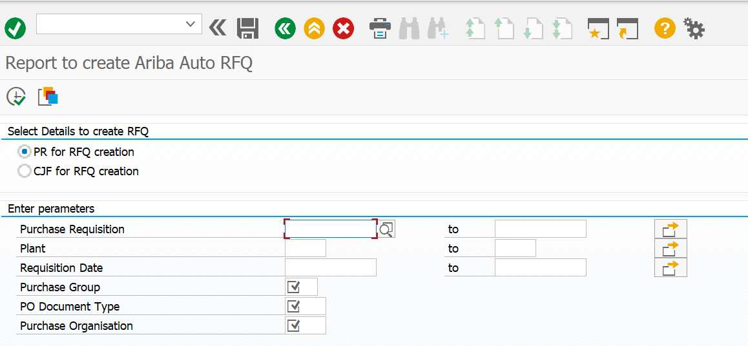

**9. Change impact to existing process**

For Sourcing module of SAP Ariba, following change impact points are identified.

|  |  |
| --- | --- |
| **Current state high level overview** | **Future State** |
| RFI process - RFI via mail or on phone | Sending of RFI / getting the response from supplier shall be via Sourcing module with system driven / dynamic questionnaire |
| RFP process - RFP via mail or on phone | Sending of RFP / getting the response from supplier shall be via Sourcing module with system driven control on event, getting the online quote, intermediate communication / negotiation |
| Auction - standalone | The event auction shall be integrated back to PO / Contract |

**10. Configuration Details**

* Workbook Enablement data of Sourcing



* RFI Template for Vendor assessment



* **Category wise RFP Templates**
* Request for Information Vendor Assessment
* Request for Proposal Chemistry
* Request for Proposal CDS
* Request for Proposal Opex and Biology
* Request for Proposal Integrated Sourcing
* Request for Proposal Capex
* Full Project Template Capex
* Sourcing Request

**11. ADDENDUM**

Below is the name of Deployment sheets that will be covered in SAP Sourcing Deployment phase:

|  |  |  |
| --- | --- | --- |
| **Sr No** | **Name of Deployment Sheet** | **Version** |
| 1 | Strategic Sourcing- Enablement Workbook | Initial |
| 2 | Strategic Sourcing- Sourcing Process Design Matrix | Initial |
| 3 | Strategic Sourcing- RFP Data Collection Template | Initial |
| 4 | Strategic Sourcing- Custom Header Field Data Collection Template | Initial |

**12. APPENDIX**

**12.1 Requirement Gathering Sheet**

|  |  |
| --- | --- |
| Requirements | Count |
| Total number of requirements | 49 |
| Standard | 28 |
| Non-Standard | 21 (15 in scope, 6 out of scope) |



**12.2 Authorization Control Matrix**

|  |  |
| --- | --- |
| Role | General Responsibilities* |
| Sourcing Executive | Person who is responsible for creating Sourcing events, inviting supplier in event, creating scenario and trigger tasks |
| Category/Procurement Manager | Person who is responsible for review of the event published by sourcing executive and approving the task initiated |
| Supplier | Person who is responsible for Submitting the RFQ event response submission |

**13. Glossary**

|  |  |
| --- | --- |
| **ID** | **Description** |
| **BBP** | Business Blueprint |
| **BPO** | Business Process Owner |
| **BPL** | Business Process Lead |
| **BPML** | Business Process Master List |
| **SAP** | System Application & Product and Data Processing |
| **MM** | Material Management |
| **PR** | Purchase Requisition |
| **CIG** | Cloud Integration Gateway |
| **SR** | Sourcing Request |
| **RFI** | Request for Information |
| **RFP** | Request for Proposal |
| **QCS** | Quote Comparison Statement |
| **DOA** | Delegation of Authority |
| **SIT** | System Integration Test |
| **UAT** | User Acceptance Test |

Version - 2 – Updated Requirements

* **Additional Requirements discussed on 16th Aug 2023, 17th Aug 2023, and 18th Aug 2023 during demo sessions.**

1. PR document type need to be added in ZARB_RFQ screen which will help buyer to filter which all PR need to be converted to RFQ.

2. Header fields – Department and Commodity should be auto picked from SAP in an integrated scenario.

3. Default event duration and the reminder to be set at template level. If required buyer will change the same while event creation.

4. System should generate some warning whenever two same supplier groups are being created with the same set of suppliers; a pop should come up showing that the supplier already exists in another supplier group – as confirmed by SAP this is not possible.

5. While adding supplier in an event system should also display the supplier SAP code which will help buyer to select the correct supplier to whom enquiry need to be sent.

6. Catalogue number should be participant specific which means buyer will share the different catalogue number to different supplier.

7. Event team should get auto populated while creation.

8. While sending the enquiry to supplier, subject of invitation email should contain the Doc Id of the event.

9. Lead Term should be in date format

10. Rank should be visible at both line-item level and on the total cost.

11. Matrix needs to be configured for quantity term for tier pricing.

12. Certain questions should not be visible in case of import vendor participation.

13. For capex projects excel upload functionality is required where buyer will upload the BOQ and share with supplier for detail pricing and header line-item price will be submitted by supplier at line-item level.

14. Department should get auto selected based on the buyer.

**\*\* Note-**

All these additional requirements, we will check feasibility internally and with SAP & then comment on it. These requirements and any additional Ad-hoc requirements EY & Aragen will have to discuss/communicate through separate email communication ( either for current scope as per timeline Or for Change request etc.) instead of amending BRD documents.